**Juno Lamp V1 User Manual**

Author: Zipeng Wang

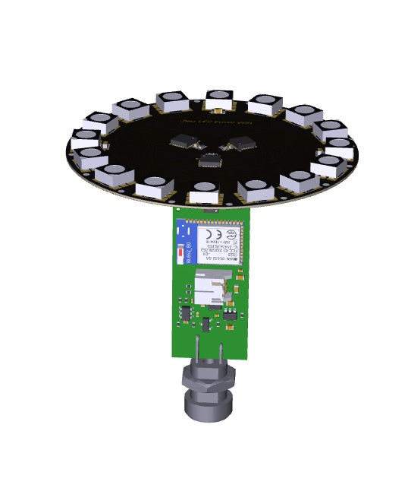

***Congratulations, you are now an owner of the Juno Lamp V1 system.***

**Display Modes:**

There are currently eleven modes that the Juno Lamp system is capable of displaying:

* **DISPLAY_BATTERY_MODE:**

This mode displays the battery level through the LED light. Red means depletion, Yellow means 50% battery and green means close to 100% battery. The color will smoothly transition from green to yellow to red on a fully charged battery.

* **DISPLAY_YELLOW_MODE:**

This mode displays yellow color on all LEDs.

* **DISPLAY_RED_MODE:**

This mode displays red color on all LEDs.

* **DISPLAY_GREEN_MODE:**

This mode displays green color on all LEDs.

* **DISPALY_BLUE_MODE:**

This mode displays blue color on all LEDs.

* **DISPLAY_ORANGE_MODE:**

This mode displays orange color on all LEDs.

* **DISPLAY_MOTION_MAP_ MODE:**

This mode maps the rotation of the lamp to LED display color, the LED light will change based on yaw, pitch, roll rotation.

* **DISPLAY_COLOR_TRANSITION_ MODE:**

This mode transitions the LEDs from yellow to red in a train forward fashion.

* **DISPLAY_SIN_ MODE:**

This mode maps system time to sine functions so the display will be time depend. This is also what I call a “BACKDOOR OTA MODE” for the lamp, when the lamp is transitioned to SIN_DISPLAY mode, bluetooth will start its broadcast under the name “Juno”. The user can then use “nRF Toolbox” app to wireless update the lamp to the latest version. This backdoor ensures a longer lifecycle of this device.

* **DISPLAY_COS_ MODE:**

This mode maps system time to cosine functions so the display will be time depend.

* **DISPLAY_SIN_PLUS_COS_ MODE:**

This mode maps system time to sine and cosine functions so the display will be time depend.

**Operation of the Lamp:**

The user can turn the hand on or off through the touch ring. Once the hand is powered on and initialized, the user can further control the hand through tap sensing. The user can charge the battery through the charging port that also functions as the touch ring:

* **Touch Ring:**

The Juno Lamp uses the touch ring in the bottom to control the on/off of the lights. One touch of the ring, the lamp turns on to display blue color indicating initialization. Once initialized, the Juno Lamp will go to DISPLAY_BATTERY_MODE mode.

When the user touches the touch ring to turn the power off, the lamp will go into low power sleep mode, consuming 1.55mA. The battery is rated to be 400mAh, so the lamp itself can sleep for 11 days before depleting the battery.

* **Tap Control:**

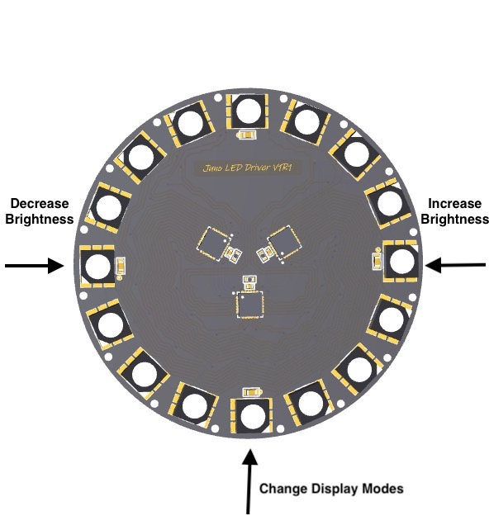Tapping controls are used to transition between each display modes as well as control the brightness.

Figure 1: Tap Control on PCB

For PCB users: Follow figure 1. Tap the rim of the LED ring with your finger at indicated locations for the tap control.

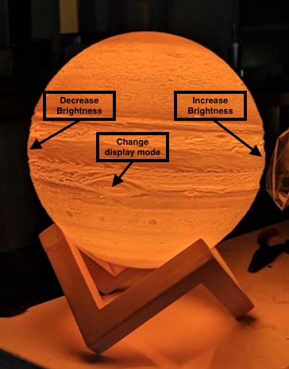For lamp users: The eye of the Jupiter is designed to be the front of the lamp. Follow Figure 2. Pat the eye of the Jupiter with your hand to switch between modes, pat the sides of the Jupiter to control the brightness, pat left decreases brightness, pat right increases brightness.

Figure 2: Tap Control on Lamp

The tap or pat strength the user needs to exert onto the Juno Lamp should range from light to moderate strength. Too high of a tapping or patting strength can result in mis taps registered from other directions. For example, one strong tap can result in mode changing as well as brightness increase.

* **Battery and Charging**

The battery installed in the lamp is a single cell 400mAh li-ion battery with full protection circuitry protecting the battery from over voltage, under voltage and external short damages. The user can put the lamp into two modes when charging the battery:

* **Display charging mode:** the user needs to plug the USB end of the charging cable into charger first, then plug the round end into the bottom of the lamp, the lamp will initialize itself and enters SINGLE_COLOR_DISPLAY_BATTERY mode. The color of the lamp will start from red or yellow or green, depending on the remaining battery charge, then transitions into green. Once the battery is fully charged, the lights will turn off.
* **Dark charging mode:** the user needs to plug the round end of the charging cable into the bottom of the lamp first, then plug the USB end to the charger, no light should come up during a charging cycle.

A typical charge cycle takes two hours to finish for a completely depleted battery.

Have fun with the LAMP! Put it in **DISPLAY_MOTION_MAP_ MODE** and toss it into the sky to see the beautiful color transitions! Any bugs or issues discovered please report to [wangzipeng1992@gmail.com](mailto:wangzipeng1992@gmail.com). All the design efforts are stored in private github repositories. If interested, email [wangzipeng1992@gmail.com](mailto:wangzipeng1992@gmail.com) to gain access to the github repos.